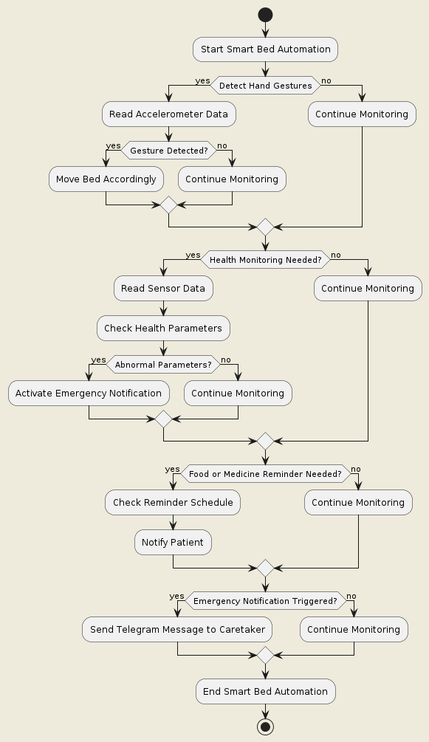
This flowchart represents the Smart bed automation process for elders and patients using Arduino. It involves detecting hand gestures through an accelerometer, monitoring health parameters using various sensors, reminding patients of food and medicine intake, and sending emergency notifications to caretakers via Telegram.

